9. Cluster Points into Clusters

9.1 Problem description
Cluster points into k clusters. Use iterative improvement, divide-and-conquer, and Brute Force to solve this problem.
Clustering is a fundamental task in data mining and unsupervised learning, focused on partitioning a set of objects into groups, or clusters, such that objects within the same group are more like each other than to those in other groups.
This project explores the implementation and performance of three distinct algorithmic paradigms: Divide and Conquer (Agglomerative), Brute Force (Exhaustive Search), and Iterative Improvement (K-Means).

9.2 Assumptions
- Points are 2D with x- and y-coordinates.
- Euclidean distance: similarity between points and clusters is measured using Euclidean distance.
- Fixed cluster distance metric: the distance between two clusters is defined as the distance between their centroids.
- Centroid-based clustering: each cluster is represented by its centroid.
- Clustering Bias: points are assigned to clusters based on the minimum distance to a cluster’s centroid.
- Convergence criterion: In iterative improvement, convergence is declared when all new centroids in an iteration are exactly equal to the previous one.
- Initial centroids are data points: For iterative improvement, initial centroids are randomly chosen from the given points, not generated arbitrarily in continuous space.
- Base case: defined as `k == 1` or `k >= number of points`, handled by returning either all points in one cluster or each point as its own cluster.
- Deterministic brute force: Brute force enumerates all distinct assignments.
- Divide‑and‑conquer order: points are split by index order (first half / second half).
- No ties in nearest centroid: in nearest‑centroid assignment, if a point is equidistant from two centroids, the code picks the first encountered centroid.
- No randomness control: Random shuffling for iterative improvement uses `random_shuffle` without seeding, so results may vary across runs.
- Single‑run output: each algorithm returns the first converged/optimal solution without multiple restarts to avoid local optima.

9.3 Methodology

9.3.1 Brute-Force
Step-by-Step description (pseudocode in English).
- Generate all possible combinations of clustering points into k clusters.
- Try each one using the points.
- Compute the score of each combination.
  - The score is the distance between each cluster’s centroid and the points inside of it for a given combination.
  - The best score is the minimum distance across all clusters.
- The combination with the best score is the optimal result.
- Print the best combination.

9.3.2 Divide and Conquer
- Divide the points two parts: left and right.
- For each part divide again until the number of points is equal to or less than the number of clusters (k).
- Then merge all the parts together.
  - Append the right clusters to the left clusters, generating 2k clusters.
  - While the number of clusters in the combined list is greater than k, repeatedly merge the two closest clusters.
  - For every pair of distinct clusters i and j, calculate the distance between them using the centroid distance method:
    - Compute the centroid (average point) of each cluster.
    - Calculate the Euclidean distance between these two centroids.
  - Find the closest pair and merge it by adding all points from the second cluster to the first cluster.
  - Remove the second cluster from the list.
  - Repeat until only k clusters remain.
- Return the merged clusters.
- At the end of the recursion cycle, the final clustering remains.

9.3.3 Iterative Improvement
- Create k clusters each containing a random point from the points list; thus, a cluster is never empty.
- Repeat until convergence:
  - Assign each point to its nearest cluster.
  - Find the mean point of these points, this will be the new centroid of the cluster (iterative improvement step).
  - If the new centroid is nearly equal to the old one, then convergence occur. If not, repeat.
- Return the final clusters.

9.4 Pseudocode

9.4.1 Helper Functions
function eachPointAsCluster(points):
clusters <- empty list
for each point in points:
clusters.append([point]) // singleton cluster
return clusters

function clusterDistance(clusterA, clusterB):
centroidA <- computeCentroid(clusterA)
centroidB <- computeCentroid(clusterB)
return distance(centroidA, centroidB)

function computeCentroid(cluster):
// The centroid is the mean point of all the points in a cluster
if cluster is empty:
return Point(0, 0)

sumX <- 0
sumY <- 0
for each point in cluster:
sumX <- sumX + point.x
sumY <- sumY + point.y
return Point(sumX / length(cluster), sumY / length(cluster))

function distance(pointA, pointB):
// Euclidean distance
dx = pointA.x - pointB.x
dy = pointA.y - pointB.y
return sqrt(dx*dx + dy*dy)
function isBaseCase(points, k):
return (k == 1) or (k >= length(points))

9.4.2 Brute-Force
function bruteForceClusters(points, k):
if k = 1:
return [points]
if length(points) <= k:
return eachPointAsCluster(points)

// Generate all valid partitions
allAssignments <- empty list
combination <- array (length(points))
generateAllCombinations(points, 0, combination, k, 0, allAssignments)

// Find assignment with minimum score
bestScore <- INFINITY
bestAssignment <- empty list

for each combination in allAssignments:
score <- calculatePartitionScore(points, combination, k)
if score < bestScore:
bestScore <- score
bestAssignment <- assignment

// Build clusters from best combination
clusters <- empty list
for i <- 0 to length(points)-1:
clusterId = bestAssignment[i]
clusters[clusterId].append(points[i])
return clusters

function generateAllCombinations(points, index, combination, k, usedClusters, allAssignments):
n <- length(points)
remaining <- n - index
neededClusters <- k - usedClusters

// Pruning: not enough remaining points to fill needed clusters
if remaining < neededClusters:
return
// Base case: all points assigned
if index = n:
if usedClusters = k: // only keep full cluster assignments
allAssignments.append(copy of combination)
return

// First point always goes to cluster 0 (to avoid symmetric duplicates)
if index = 0:
combination[index] <- 0
generateAllCombinations(points, index+1, combination, k, 1, allAssignments)
return

// Case 1: assign to an existing cluster
for cluster <- 0 to usedClusters-1:
combination[index] <- cluster
generateAllCombinations(points, index+1, combination, k, usedClusters, allAssignments)

// Case 2: assign to a new cluster (if available)
if usedClusters < k:
combination[index] <- usedClusters
generateAllCombinations(points, index+1, combination, k, usedClusters+1, allAssignments)

function calculatePartitionScore(points, combination, k):
// Output: sum of distances from each point to its cluster's centroid

// Build clusters from combination
clusters <- empty list
for i <- 0 to k-1:
clusters.append(empty list)

for i <- 0 to length(points)-1:
clusterId <- combination [i]
clusters[clusterId].append(points[i])

// Calculate total score
totalScore <- 0
for each cluster in clusters:
centroid <- computeCentroid(cluster)
for each point in cluster:
totalScore <- totalScore + distance(point, centroid)
return totalScore

9.4.3 Divide and Conquer
function divideAndConquerClusters(points, k):
if length(points) <= k:
return eachPointAsCluster(points)

// Divide
middle <- floor(length(points) / 2)
leftPoints <- points[0 .. middle-1]
rightPoints <- points[middle .. end-1]

// Conquer
leftClusters <- divideAndConquerClusters(leftPoints, k)
rightClusters <- divideAndConquerClusters(rightPoints, k)

// Combine
combined <- leftClusters + rightClusters // concatenate lists
return mergeClusters(combined, k)

function mergeClusters(clusters, targetCount):
// integer targetCount is k
while length(clusters) > targetCount:
// Find closest pair of clusters
minDistance <- INFINITY
firstIndex <- 0
secondIndex <- 1

for i <- 0 to length(clusters)-1:
for j <- i+1 to length(clusters)-1:
distance <- clusterDistance(clusters[i], clusters[j])
if distance < minDistance:
minDistance <- distance
firstIndex <- i
secondIndex <- j

// Merge the closest pair
for each point in clusters[secondIndex]:
clusters[firstIndex].append(point)
remove clusters[secondIndex] // Remove the second cluster

return clusters

9.4.4 Iterative Improvement
function iterativeImprovementClusters(points, k):
// Base cases
if k = 1:
return [points] // single cluster containing all points
if length(points) <= k:
return eachPointAsCluster(points)

// Initialize centroids with k random distinct points from the input
indices <- [0, 1, 2, ..., length(points)-1]
randomShuffle(indices) // generates random order

centroids <- empty list
for i <- 0 to k-1:
randomIndex <- indices[i]
centroids.append(points[randomIndex])

// Iterative improvement loop
while true:
// Assignment step: assign each point to nearest centroid
clusters <- assignPointsToNearestCluster(points, centroids)

// Update step: compute new centroids
newCentroids <- empty list
converged <- true
for i <- 0 to k-1:
newCentroid <- computeCentroid(clusters[i])
newCentroids.append(newCentroid)
if newCentroid != centroids[i]:
converged <- false
if converged:
return clusters
// Prepare for next iteration
centroids <- newCentroids

function assignPointsToNearestCluster(points, centroids):
clusters <- empty list
for i <- 0 to length(centroids)-1:
clusters.append(empty list)

for each point in points:
nearestIndex <- 0
minDistance <- distance(point, centroids[0])

for i <- 1 to length(centroids)-1:
dist <- distance(point, centroids[i])
if dist < minDistance:
minDistance <- dist
nearestIndex <- i

clusters[nearestIndex].append(point)

return clusters

9.5 Code implementation

9.5.1 Helper code
#pragma once
#include <bits/stdc++.h>
using namespace std;

class Point
{
private:
double x, y;
static constexpr double EPSILON = 1.0;

public:
Point(double x, double y) : x(x), y(y) {}

double getX() const { return x; }
double getY() const { return y; }

double distanceTo(const Point &other) const
{
double dx = x - other.x;
double dy = y - other.y;
return sqrt(dx * dx + dy * dy);
}

bool operator==(const Point &other) const
{
return abs(x - other.x) < EPSILON && abs(y - other.y) < EPSILON;
}

bool operator!=(const Point &other) const
{
return abs(x - other.x) >= EPSILON || abs(y - other.y) >= EPSILON;
}

void print() const
{
cout << "(" << x << ", " << y << "), ";
}
};

using Cluster = vector<Point>;

bool isBaseCase(const vector<Point> &points, int k)
{
return k == 1 || k >= (int)points.size();
}

vector<Cluster> eachPointAsCluster(const vector<Point> &points)
{
vector<Cluster> clusters;
for (const Point &p : points)
clusters.push_back({p});
return clusters;
}

Point computeCentroid(const vector<Point> &points)
{
double totalX = 0, totalY = 0;
for (const Point &p : points)
{
totalX += p.getX();
totalY += p.getY();
}
return Point(totalX / points.size(), totalY / points.size());
}

double clusterDistance(const Cluster &a, const Cluster &b)
{
Point centroidA = computeCentroid(a);
Point centroidB = computeCentroid(b);
return centroidA.distanceTo(centroidB);
}

void printClusters(const vector<Cluster> &clusters)
{
for (int i = 0; i < (int)clusters.size(); i++)
{
cout << " Cluster " << i + 1 << ": ";
for (const Point &p : clusters[i])
p.print();
cout << "\n";
}
}

9.5.2 Brute-Force
#include "ClustersHelper.hpp"
using namespace std;

// Using Stirling numbers of the second kind
void generateAllCombinations(
const vector<Point> &points,
int index,
vector<int> &combination,
int k,
int usedClusters,
vector<vector<int>> &allAssignments)
{
int n = points.size();

// Prune when not enough remaining points
int remaining = n - index;
int neededClusters = k - usedClusters;
if (remaining < neededClusters)
return;

// Return when all points assigned
if (index == n)
{
if (usedClusters == k) // Only assignments that have filled clusters
allAssignments.push_back(combination);

return;
}

// Always assign to cluster 0 to avoid symmetric duplicates
if (index == 0)
{
combination[index] = 0;
generateAllCombinations(points, index + 1, combination, k, 1, allAssignments);
return;
}

// Assign to existing clusters
for (int cluster = 0; cluster < usedClusters; cluster++)
{
combination[index] = cluster;
generateAllCombinations(points, index + 1, combination, k, usedClusters, allAssignments);
}

// Assign to new cluster if there are any
if (usedClusters < k)
{
combination[index] = usedClusters;
generateAllCombinations(points, index + 1, combination, k, usedClusters + 1, allAssignments);
}
}

// Score is evaluated as sum of distances to centroid
double calculatePartitionScore(const vector<Point> &points, const vector<int> &combination, int k)
{
vector<Cluster> clusters(k);
for (int i = 0; i < (int)points.size(); i++)
clusters[combination[i]].push_back(points[i]);

double totalScore = 0;
for (const Cluster &cluster : clusters)
{
Point centroid = computeCentroid(cluster);
for (const Point &point : cluster)
totalScore += point.distanceTo(centroid);
}
return totalScore;
}
vector<Cluster> bruteForceClusters(const vector<Point> &points, int k)
{
if (isBaseCase(points, k))
return k == 1 ? vector<Cluster>{points} : eachPointAsCluster(points);

vector<vector<int>> allPartitions;
vector<int> assignment(points.size(), 0);
generateAllCombinations(points, 0, assignment, k, 0, allPartitions);

double bestScore = INT_MAX; // minimum distance to centroid
vector<int> bestAssignment;
for (const vector<int> &partition : allPartitions)
{
double score = calculatePartitionScore(points, partition, k);
if (score >= bestScore)
continue;

bestScore = score;
bestAssignment = partition;
}

vector<Cluster> clusters(k);
for (int i = 0; i < points.size(); i++)
{
auto cluster = bestAssignment[i];
clusters[cluster].push_back(points[i]);
}

return clusters;
}

int main()
{
vector<Point> points = {
Point(1, 2), Point(3, 4), Point(5, 6),
Point(7, 8), Point(9, 10), Point(11, 12),
Point(13, 14), Point(15, 16), Point(17, 18), Point{19, 20}};

vector<int> testCases = {2, 3, 4, 5};
for (int test : testCases)
{
cout << "========== Brute Force Testing for " << test << " Clusters ==========\n";
printClusters(bruteForceClusters(points, test));
cout << "\n";
}
}

9.5.3 Divide and Conquer
#include "ClustersHelper.hpp"
using namespace std;

vector<Cluster> mergeClusters(vector<Cluster> clusters, int targetCount)
{
while ((int)clusters.size() > targetCount)
{
int firstIndex = 0, secondIndex = 1;
double minDistance = clusterDistance(clusters[0], clusters[1]);

for (int i = 0; i < (int)clusters.size(); i++)
{
for (int j = i + 1; j < (int)clusters.size(); j++)
{
double distance = clusterDistance(clusters[i], clusters[j]);
if (distance < minDistance)
{
minDistance = distance;
firstIndex = i;
secondIndex = j;
}
}
}

for (const Point &p : clusters[secondIndex])
clusters[firstIndex].push_back(p);
clusters.erase(clusters.begin() + secondIndex);
}
return clusters;
}

vector<Cluster> divideAndConquerClusters(const vector<Point> &points, int k)
{
if ((int)points.size() <= k)
return eachPointAsCluster(points);

int middle = points.size() / 2;
vector<Point> leftPoints(points.begin(), points.begin() + middle);
vector<Point> rightPoints(points.begin() + middle, points.end());

vector<Cluster> leftClusters = divideAndConquerClusters(leftPoints, k);
vector<Cluster> rightClusters = divideAndConquerClusters(rightPoints, k);
vector<Cluster> combined = leftClusters;
combined.insert(combined.end(), rightClusters.begin(), rightClusters.end());

return mergeClusters(combined, k);
}

9.5.4 Iterative Improvement
#include "ClustersHelper.hpp"
using namespace std;

vector<Cluster> assignPointsToNearestCluster(const vector<Point> &points, const vector<Point> &centroids)
{
vector<Cluster> clusters(centroids.size());
for (const Point &point : points)
{
int nearestIndex = 0;
double minDistance = point.distanceTo(centroids[0]);
for (int i = 1; i < (int)centroids.size(); i++)
{
double distance = point.distanceTo(centroids[i]);
if (distance < minDistance)
{
minDistance = distance;
nearestIndex = i;
}
}
clusters[nearestIndex].push_back(point);
}
return clusters;
}

vector<Cluster> iterativeImprovementClusters(const vector<Point> &points, int k)
{
if (isBaseCase(points, k))
return k == 1 ? vector<Cluster>{points} : eachPointAsCluster(points);

// Choose centroids from random points inside the points vector
vector<Point> centroids;
vector<int> pointsIndices(points.size());
iota(pointsIndices.begin(), pointsIndices.end(), 0);
random_shuffle(pointsIndices.begin(), pointsIndices.end());
for (int i = 0; i < k; i++){
int randomPoint = pointsIndices[i];
centroids.push_back(points[randomPoint]);
}

while (true)
{
vector<Cluster> clusters = assignPointsToNearestCluster(points, centroids);

vector<Point> newCentroids;
bool converged = true;
for (int i = 0; i < k; i++)
{
// compute the mean point of the points in a cluster
// this mean point is the new cluster centroid (iterative improvement step)
Point newCentroid = computeCentroid(clusters[i]);
if (newCentroid != centroids[i])
converged = false;

newCentroids.push_back(newCentroid);
}

if (converged)
return clusters;

centroids = newCentroids;
}
}

9.6 Test cases

9.6.1 Chosen test cases
Test Case for Brute Force (Only 10 Points due to its the super-exponential nature):
vector<Point> points = {
Point(1, 2), Point(3, 4), Point(5, 6),
Point(7, 8), Point(9, 10), Point(11, 12),
Point(13, 14), Point(15, 16), Point(17, 18), Point{19, 20}
};

Test Case for Iterative Improvement and Divide-and-Conquer:
vector<Point> points = {
Point(2, 3), Point(3, 2), Point(4, 5), Point(5, 4), Point(6, 3),
Point(1, 6), Point(7, 2), Point(3, 7), Point(4, 4), Point(5, 5),
Point(11, 12), Point(12, 11), Point(13, 14), Point(14, 13), Point(15, 12),
Point(10, 15), Point(16, 11), Point(12, 16), Point(13, 13), Point(14, 14),
Point(20, 21), Point(21, 20), Point(22, 23), Point(23, 22), Point(24, 21),
Point(20, 24), Point(25, 22), Point(22, 25), Point(23, 23), Point(24, 24)
};

9.6.2 Output
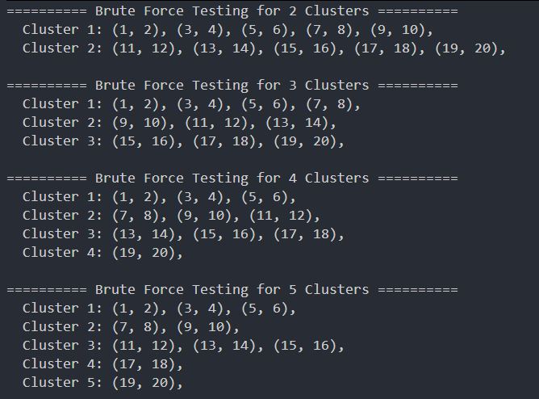

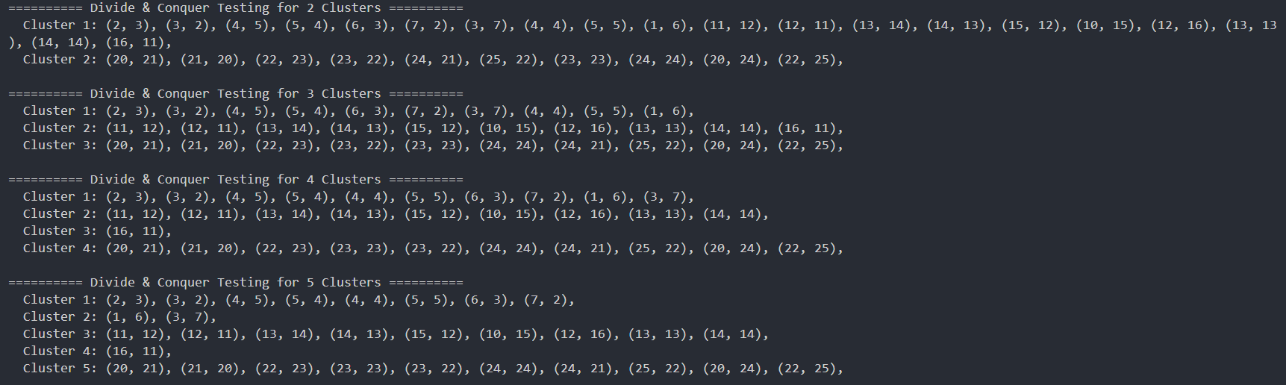

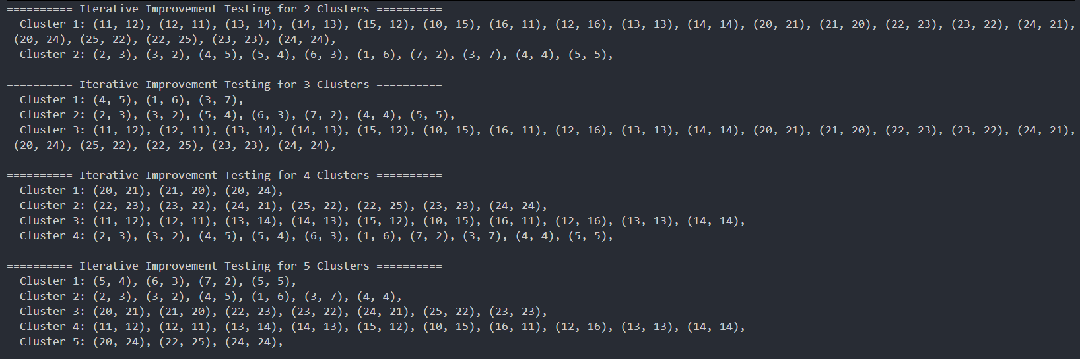
In the iterative improvement implementation, A significant drawback of selecting initial centroids randomly is the algorithm's extreme sensitivity to these starting positions, which often leads to local optima where the final clusters fail to represent the true underlying patterns of the data.
This randomness can cause "crowding," where multiple centroids begin in the same dense region, or "isolation," where a centroid is placed so far from data points that it becomes orphaned or produces suboptimal, unbalanced partitions.
Other methods to overcome these weaknesses:
- K-means++: is the industry-standard alternative; it initializes centroids by selecting points that are mathematically distant from one another, significantly improving the speed of convergence and the quality of the final clustering.
- Bradley-Fayyad-Reina (BFR) approach: which utilizes statistical summaries to handle very large datasets.
- The CURE algorithm, which uses multiple representative points instead of a single centroid to better accommodate clusters with non-spherical or irregular shapes.

9.7 Complexity analysis

9.7.1 Brute Force

9.7.1.1 Time complexity
The core of this code is generating every possible way to partition n points into k non-empty sets.
generateAllCombinations: This function generates partitions related to Stirling Numbers of the Second Kind.
- The number of ways to partition n elements into k non-empty subsets grows nearly exponentially.
- The exact number of iterations is roughly $O\left(\frac{k^{n}}{k!}\right)$, for which we can ignore the factorial term because the exponential is way higher.
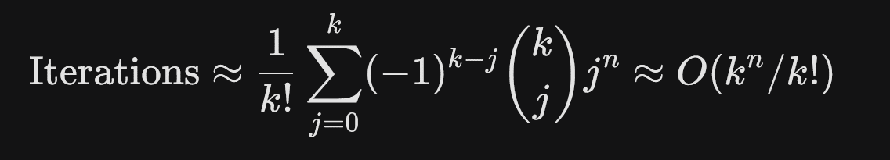
calculatePartitionScore: For every single partition generated, the code calculates a score:
- Iterate points: O(n) to assign points to clusters.
- Compute Centroids: O(n) total across all clusters.
- Calculation: O(n) to sum distances from points to centroids.
Total per partition: O(n).
Total Time Complexity:
In Big O notation, this is roughly $O\left(nk^{n}\right)$. This is why brute-forcing clusters is only feasible for very small datasets (usually n<15).

9.7.1.2 Space complexity
allPartitions Storage: Stores every valid assignment in a vector<vector<int>>.
Recursion Stack: The depth is O(n), which is negligible compared to the storage of the partitions.
Total Space: $O\left(nk^{n}\right)$.

9.7.2 Divide and Conquer

9.7.2.1 Time complexity
1. Complexity of mergeClusters
This function is the bottleneck. It repeatedly merges the two closest clusters until the count reaches targetCount.
Outer While Loop: Runs m−k times (where m is the initial number of clusters). In the merge step of the recursion, m=2k, so it runs roughly k times.
Nested For Loops: To find the minDistance, it compares every pair of clusters. If there are m clusters, this takes O(m2) comparisons.
Distance Calculation: clusterDistance calculates centroids. This depends on the number of points in the clusters, which can be up to N.
Vector Operations: clusters.erase() is O(m) because it shifts elements.
Complexity for one merge call: Since m is proportional to k during the recursion, this function behaves as $O\left(k^{3}+N\right)$.
2. Complexity of divideAndConquerClusters
Recurrence Relation:
$$T\left(N\right)=2T\left(\frac{N}{2}\right)+mergeClusters\left(2k,k\right)$$

Base Case: When N ≤ k, it returns N clusters (each point is its own cluster).
Recursive Work: The "Divide" step takes O(N) to copy points into leftPoints and rightPoints.
Combining Step: The mergeClusters function is called at every level of the tree.
- Overall Time Complexity
Because the mergeClusters step is applied at each level of the recursion and its complexity depends heavily on k (which is constant relative to N in most calls), the overall complexity is:
$$O\left(N\log{N}+\text{levels}×k^{3}\right)$$

However, if k is small, the $O\left(N\log{N}\right)$ dominates due to the slicing and copying of vectors at each level. If k is large, the $O\left(k^{3}\right)$ merges at each level become the primary cost.

9.7.2.2 Space complexity
The space complexity is dominated by the recursion stack and the creation of new vectors:
Stack Depth: O(logN) due to the halving of points.
Vector Storage: At each level, you are creating new vector<Point> objects. Since each point exists in only one branch of the tree at a time, the storage for points across one level is O(N).
Total Space: O(NlogN) in the worst case due to the way vectors are copied and passed in this specific C++ implementation. (Note: Passing by reference or using std::span could reduce this to O(N)).

9.7.3 Iterative Improvement

9.7.3.1 Time complexity
The time complexity is sensitive to the number of points (n), the number of clusters (k), and the number of iterations required to reach convergence (I).
A. Initialization
- Generating indices and shuffling: O(n) using random_shuffle (or std::shuffle).
- Selecting the first k points: O(k).
Total: O(n).
B. Assignment Phase (assignPointsToNearestCluster)
- For each of the n points, the algorithm calculates the distance to all k centroids.
Total per iteration: O(n⋅k).
C. Update Phase (computeCentroid)
- The algorithm iterates through all clusters and their constituent points to calculate the new mean.
- Since every point belongs to exactly one cluster, the total work across all clusters is O(n).
Total per iteration: O(n).
D. Overall Time Complexity
The total complexity is expressed as:
$$O\left(I×n×k\right)≈O\left(n^{3}\right)$$
- n: Number of points (30 in the example).
- k: Number of clusters.
- I: Number of iterations until convergence.

9.7.3.2 Space complexity
The algorithm is highly memory efficient as it does not need to store all possible combinations.
- Point Storage: The original points vector: O(n).
- Cluster Storage: The clusters vector (a partition of points): O(n).
- Centroid Storage: A small vector of k points: O(k).
Total Space: $O\left(n+k\right)≈O\left(n\right)$

9.8 Technique comparison
This section provides a comparative analysis of the three implemented clustering strategies: Divide & Conquer, Brute Force (Exhaustive), and Iterative Improvement (K-Means). Each approach offers distinct trade-offs between computational speed, memory usage, and result quality.

9.8.1 Comparative Summary Table
Feature | Divide & Conquer | Brute Force | Iterative Improvement
Time Complexity | $$O\left(N\log{N}+\text{levels}×k^{3}\right)$$ | O(n⋅kn) | O(I⋅n⋅k)
Space Complexity | O(NlogN) | O(n⋅kn) | O(n+k)
Optimality | Sub-optimal | Global Optimum | Local Optimum
Scalability | High | Very Low | Very High
Best Use Case | Small to medium datasets with hierarchical structures. | Establishing a "Gold Standard" for very small n (<15). | General purpose, large-scale data mining.

9.8.2 Deep dive analysis
The Brute Force approach is the only method guaranteed to find the absolute best clustering solution. However, due to its combinatorial nature (Stirling numbers of the second kind), the search space grows at a "super-exponential" rate, making it a theoretical tool rather than a practical one for real-world data.
K-Means is the most scalable of the three. By starting with k random centroids and refining them, it avoids the exponential search space. While it can get "stuck" in a local minimum (a solution that is better than its neighbors but not the best possible), its space requirement and fast convergence make it the industry standard for large datasets.
The Divide-and-Conquer approach provides a middle ground. By recursively breaking the problem into smaller subsets and merging them, it builds a "tree" of clusters. It is faster than Brute Force and provides more structural information than K-Means, but the repeated centroid recalculations and vector copying make it more memory-intensive than the iterative approach.

9.9 Alternative approaches
In addition to standard hierarchical and point assignment methods, several specialized algorithms address large datasets and non-standard cluster shapes.

9.9.1 BFR (Bradley-Fayyad-Reina) Algorithm
BFR is a variant of the k-means algorithm designed specifically for very large, disk-resident datasets.
- Assumptions: It assumes clusters are normally distributed around a centroid in Euclidean space, though standard deviations may vary across different dimensions.
- Data Processing: Data is processed one main-memory-load at a time, with points categorized into three classes:
  - Discard Set (DS): Points close enough to a cluster centroid to be summarized by simple statistics (N, SUM, and SUMSQ).
  - Compression Set (CS): Groups of points that are close to each other but not to any existing cluster centroid.
  - Retained Set (RS): Isolated points that cannot be summarized.
- Efficiency: Summarizing sets using N, SUM, and SUMSQ allows any number of points to be represented by 2d+1 values, where d is the number of dimensions.

9.9.2 CURE (Clustering Using REpresentatives) Algorithm
CURE addresses limitations in BFR and standard k-means, which often struggle with non-spherical cluster shapes or clusters at varying angles.
- Cluster Shape: Unlike centroid-based methods, CURE allows clusters to assume any shape in Euclidean space.
- Representative Points: Instead of a single centroid, each cluster is represented by a set of dispersed points moved approximately 20% toward the cluster's center.
- Process:
  - Pick a random sample of points for initial hierarchical clustering.
  - Select a sample of widely dispersed points for each resulting cluster.
  - Move these points toward the cluster centroid to create representatives.
  - Assign all remaining points in the dataset to the cluster with the nearest representative point.

9.10 Summary
- For Accuracy: Use Brute Force only for validation and testing on datasets where $n ≤15$.
- For Speed and Scale: Use Iterative Improvement for any dataset exceeding 50 points or for applications requiring real-time results.
- For Relationship Mapping: Use Divide & Conquer if the goal is to understand how smaller clusters naturally merge into larger ones (hierarchical relationships).

